3.2 System Implementation
For the admin side, Admin have to enter email and password. If correct email and password, admin can get the authority for the other pages.
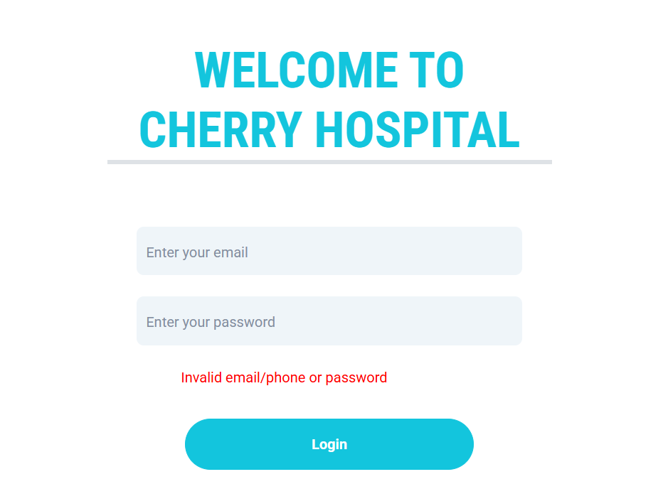
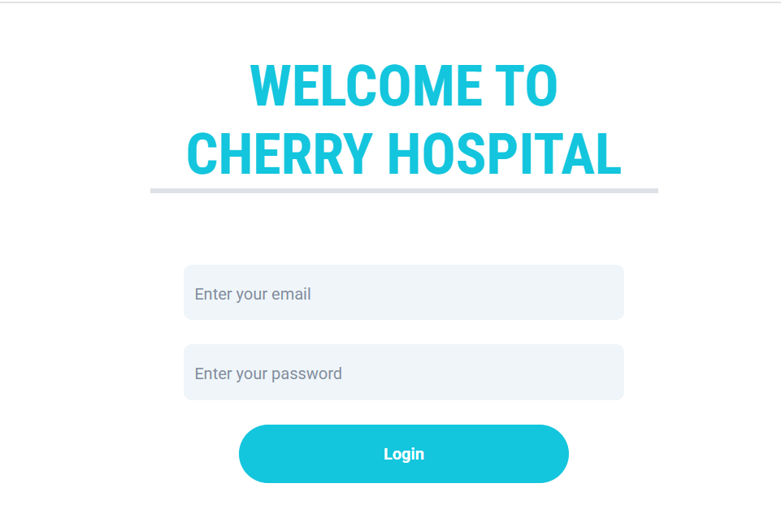

Figure : 3.2.1 Admin Login page
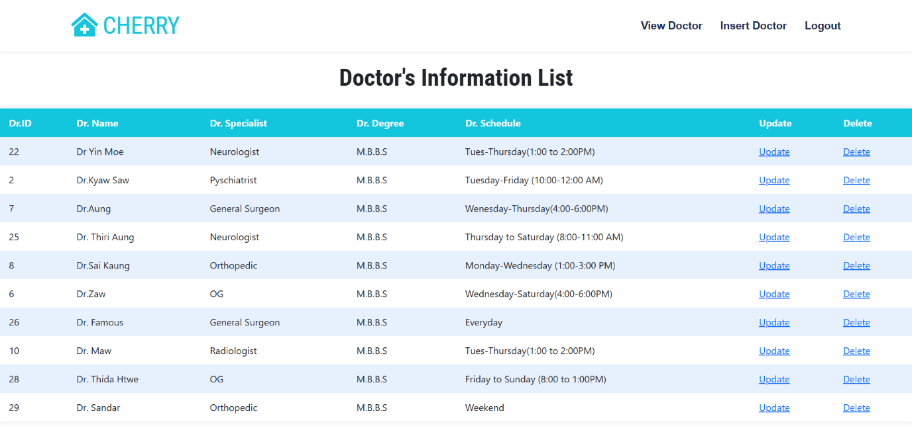
After logging in, the admin can manage the doctor’s information by adding new doctor profiles with their personal and professional details. The admin can also update existing records such as specialization, availability, or contact information. Additionally, the admin has the authority to delete outdated or incorrect doctor information from the system.

Figure : 3.2.2 Admin Home Page
This is the form where the admin can update the doctors’ information, such as name, specialization, and contact details. It allows changes to be saved directly into the system for accuracy and consistency. The form ensures that the doctors’ records remain current and reliable for future reference.
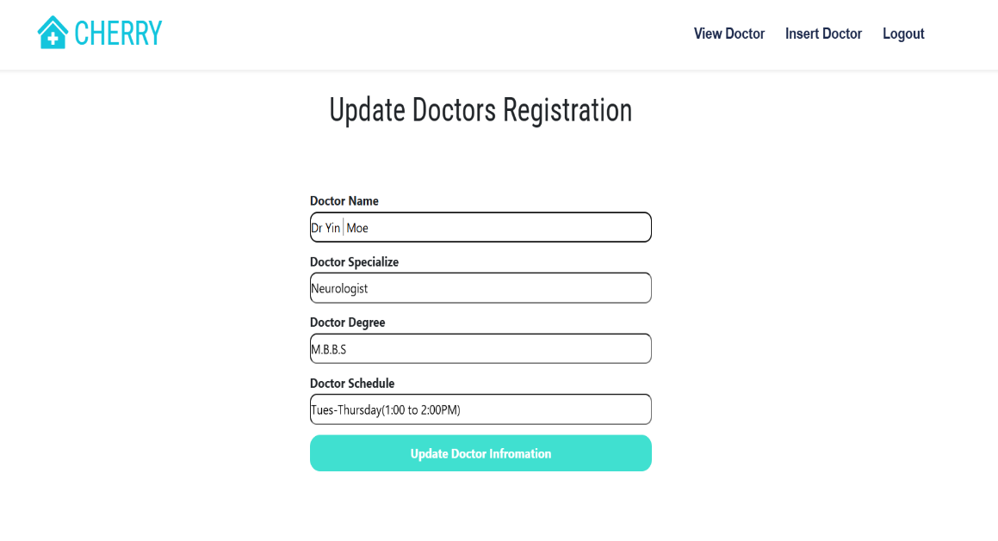
Figure: 3.2.3 Update Doctors’ Information Page
This is the form where the admin can insert new doctors’ information into the system. It allows entering details such as name, specialization, qualification, and contact information. The form helps in maintaining a complete and organized record of all doctors in the system.
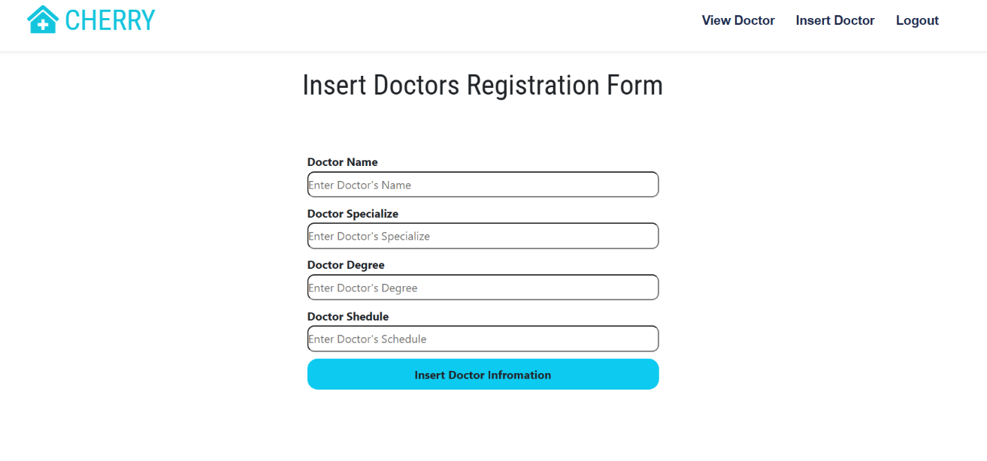
Figure 3.2.4 Insert Doctors' Information Page

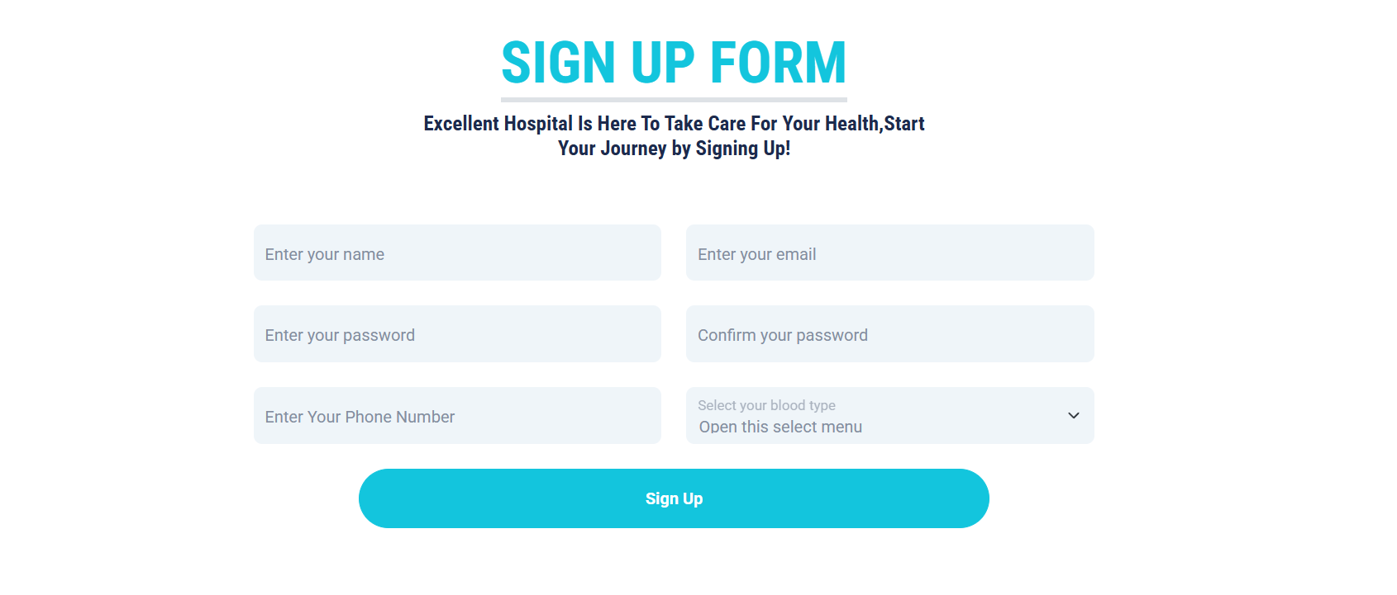
For the users, they must first sign up to create their account in the system. During sign-up, they provide basic details such as name, email, and password. Once registered, they can log in and access the features of the system.

Figure 3.2.5 User Sign Up Page
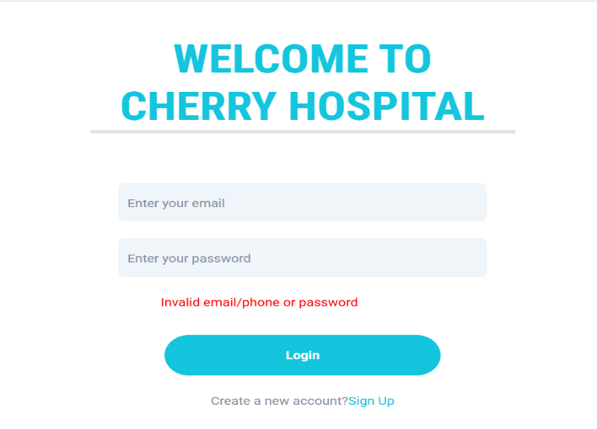
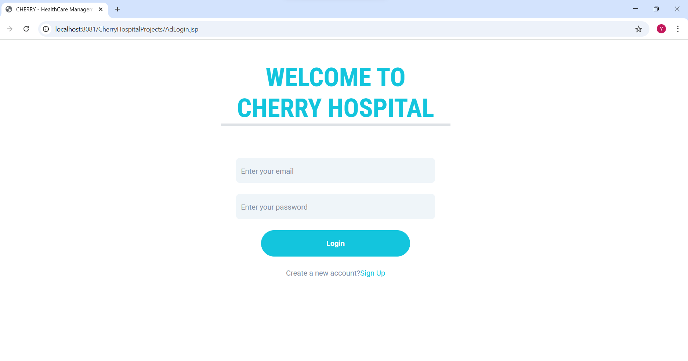
On the user side, users are required to log in by entering their registered email and password. If the email and password are correct, the system grants access, allowing them to view and navigate through the other pages. Through these pages, users can manage their profile, book doctor appointments, and access other available services provided by the system.

Figure 3.2.6 User Login Page

This is the home page of the system, which serves as the main entry point for users. On this page, users can get a brief overview of the system and its main features. It provides easy navigation to other sections, helping users quickly access the information or services they need.
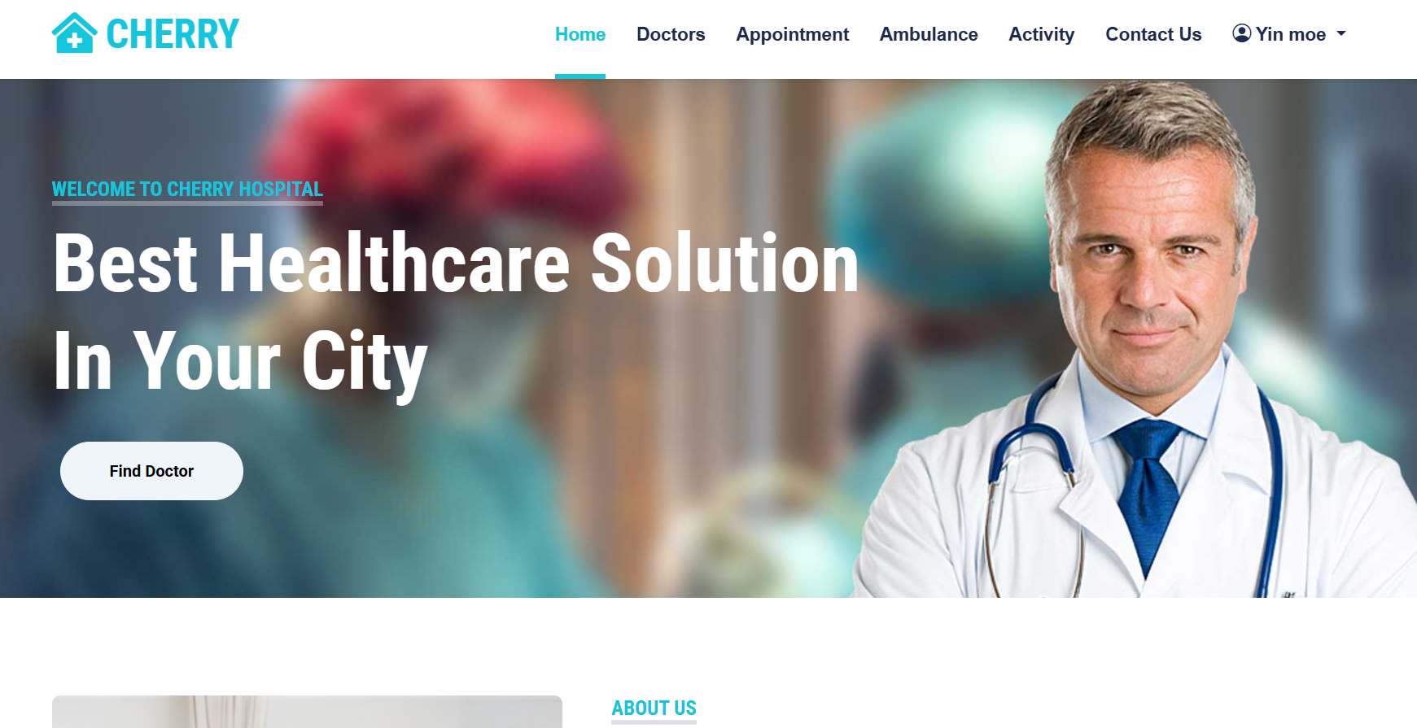
Figure : 3.2.7 User’s Home Page
In this page, users can search for doctors either by entering the doctor’s name or by selecting their specialization. This makes it easier for users to quickly find the right doctor according to their needs. The search feature ensures convenience and saves time for the users.
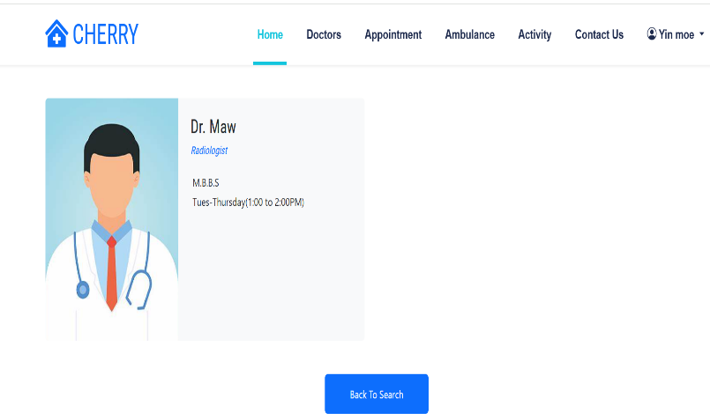
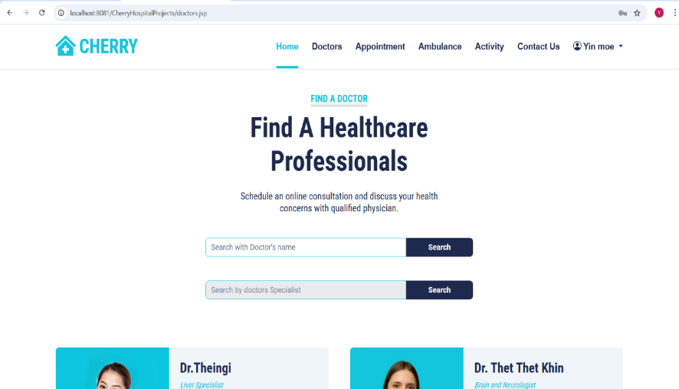

Figure: 3.2.8 Search Doctors Page

This is the Appointment page where users can conveniently book an appointment with their preferred doctor. They can select the doctor and choose the available date that best fits their schedule. This feature helps users manage their healthcare needs more efficiently.
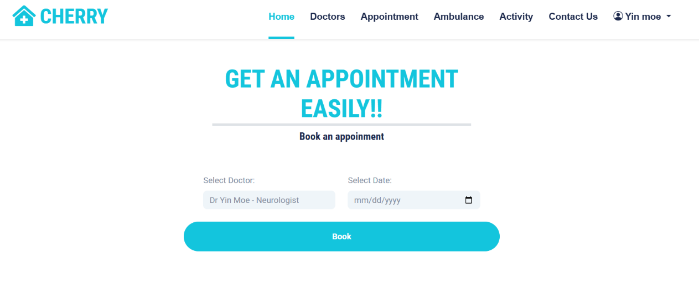
Figure: 3.2.9 User’s Appointment Page
This is the Appointment’s confirmation page where users can view the details of their appointment, including the selected doctor and date. From this page, users also have the option to re-schedule the appointment or cancel it if needed. A constraint is applied so that if a doctor is already booked by five users on the same day, no other user can make an appointment, and the system will display a message saying, “This doctor is fully booked for this day.”
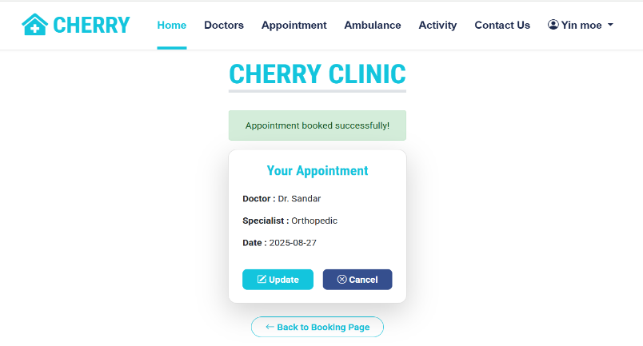
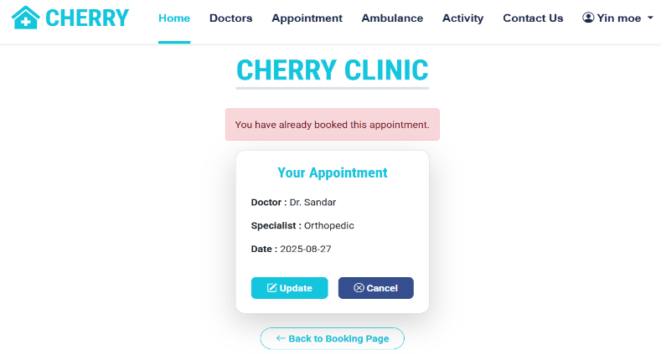

Figure: 3.2.10 Appointment’s Confirmation Page

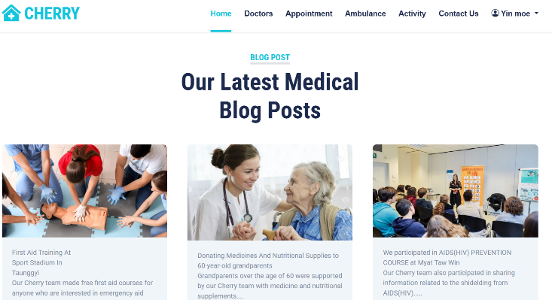
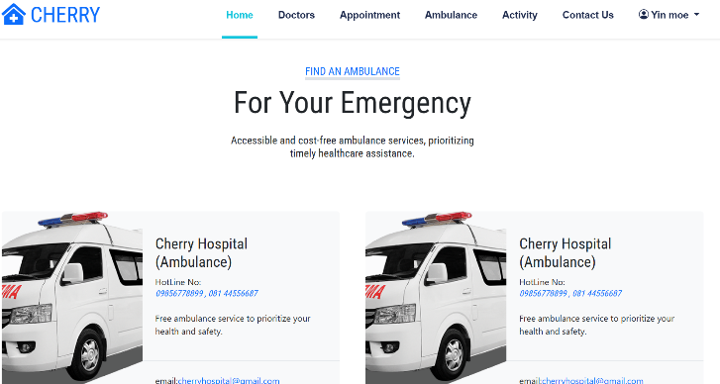
This is the Hospital’s Information page, which provides detailed information about the hospital’s facilities and services. On this page, users can view the availability of ambulances, including contact details and emergency support options. Additionally, it highlights the various activities and healthcare services offered by the hospital, helping users stay informed about what they can access when needed.

Figure: 3.2.11 Ambulance Page and Activity Page
This is the Contact page, which provides users with the hospital’s location and essential contact information. On this page, users can find phone numbers, email addresses, and other details to reach out to the hospital easily. It serves as a convenient resource for users who need to inquire about services, appointments, or any hospital-related assistance.
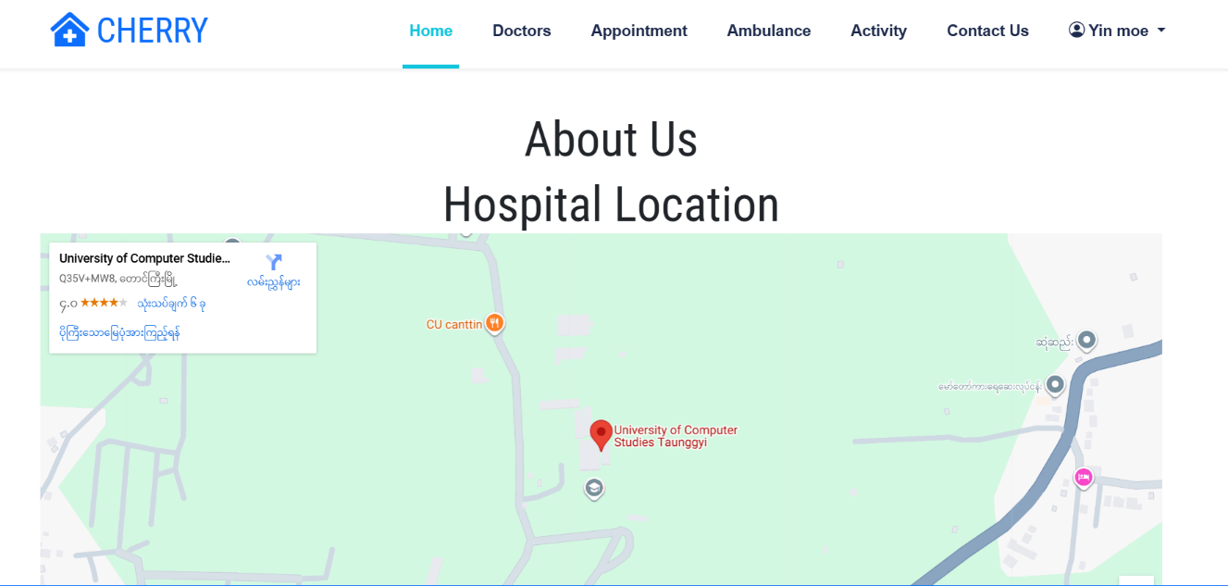

Figure: 3.2.12 Contact Us Page

This is the Profile page, where users can view their personal information and account details. On this page, users also have the option to update their credentials, such as name, email, and password. It ensures that users’ information remains accurate and up to date within the system.
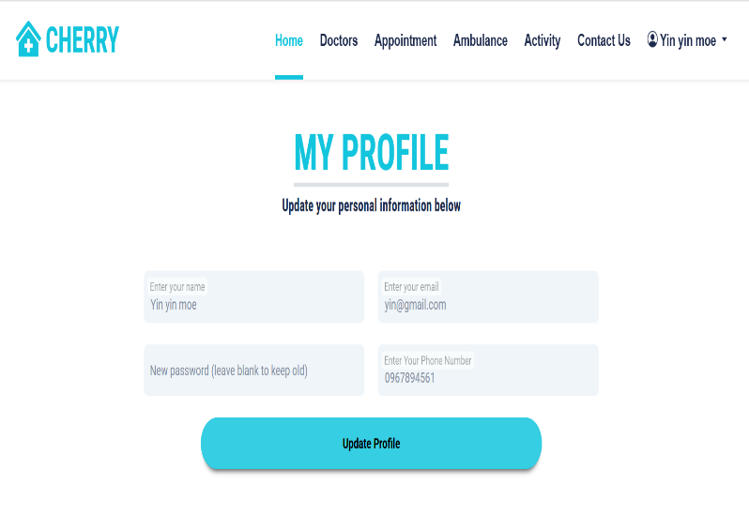
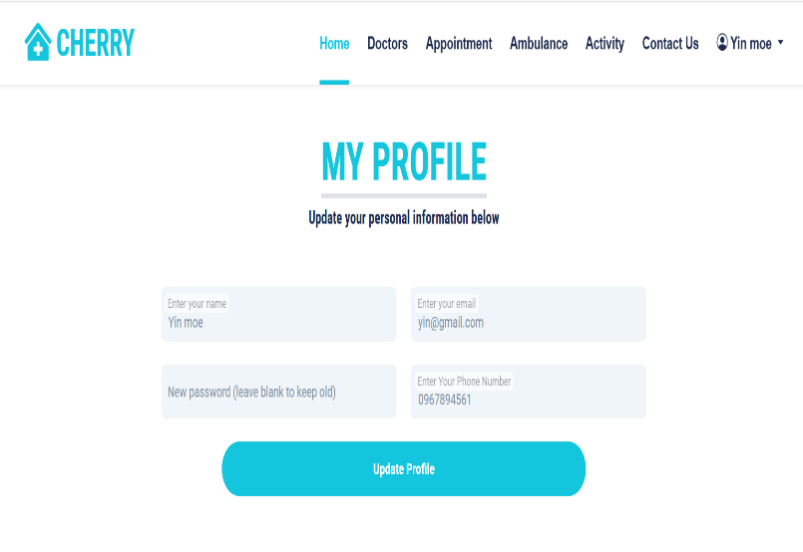

Figure: 3.2.13 Profile Page

CHAPTER 4
CONCLUSION
4.1 Conclusion
The Cherry Hospital Management System provides a streamlined platform for managing patient appointments and hospital operations. Users can view hospital information, search for doctors by name or specialty, and book appointments through the system, which checks availability and prevents duplicate or overbookings. Receptionists or administrative staff manage doctor schedules and update patient records, while the database maintains accurate information on users, doctors, and appointments. The system ensures smooth coordination between users, staff, and the database, facilitating efficient appointment management, reliable record-keeping, and overall effective hospital operations.

References
[1] https://en.wikipedia.org/wiki/Hospital_information_system
[2] https://en.wikipedia.org/wiki/Health_information_management
[3] https://en.wikipedia.org/wiki/Appointment_scheduling_software
[4] https://en.wikipedia.org/wiki/Medical_practice_management_software
[5] https://www.postgrid.com/hospital-management-system
[6] https://gloriumtech.com/hospital-management-software-development

